48 Washington Street, Suite 16
Camden, ME 04843
Phone: 236-BBBS Fax: 236-2292
info@bbbsmidmaine.org
www.bbbsmidmaine.org

Golf Fore Kids’ Sake Golfers at Martindale
Helping to Change Local Children’s Lives

Lewiston/Auburn, ME– Big Brothers Big Sister of Mid-Maine (BBBSMM) hosted its first Androscoggin fundraising golf tournament on Monday, September 25th. The event was held to raise money for the work the organization does by providing no-cost youth mentoring services to support local children facing adversity.

Martindale Country Club, in Auburn hosted the event. The day included a light breakfast, grill lunch, silent auction, and an awards ceremony and reception and a great day on a beautiful golf course. The format for the tournament was a 4-player, 18-hole best ball scramble with course challenges.

The golf tournament was part of the annual campaign to raise funds to promote and support all of BBBS of Mid-Maine programs. BBBSMM works locally with children (Littles) at Washburn Elementary, Auburn, with Big mentor volunteers from Edward Little High School. Littles at Longley, Lewiston are matched with mentors (Bigs) from Bates College.

BBBSMM provides strong and enduring, professionally supported one-to-one relationships. BBBSMM programs are proven to have a positive and dramatic impact on academic performance, attitudes and life-long behaviors.

“This first Golf Tournament in Androscoggin was an important event to support our programs,” Androscoggin Manager, Jennifer Cartmell, said. “We appreciate the generosity of the many people involved with the golf event including the golf teams, sponsors, silent auction donors and the volunteers. Through this event’s fundraising, we will be able to make significant differences in local children’s lives.”

The Silent Auction at the event included a foursome of Golf at the Boothbay Harbor Country Club, a custom jewelry piece crafted by a former BBBS manager now teaching jewelry design at MECA, and more, including a signed football and helmet sent by Steve Grogan, former Patriot Quarterback. Additional, items included a signed Rob Gronkowski football sent in support by Robert Kraft’s office.

"The work Big Brothers Big Sisters of Mid-Maine is doing in Androscoggin for children facing adversity is so very important." stated Grogan, "Though I wasn’t able to participate in the Golf Tournament at Martindale this year, I am hoping I will be golfing with the organization next year to help the programs that are changing lives of children in Lewiston and Auburn.”

Volunteers at the event included Bates College Golf Team members: Jay “Bennett” Salzman (men’s golf team) and Chelsea Anglin (Captain of the women’s golf team). Par Sponsors included Bangor Savings Bank and Morningstar Stone and Tile. Lunch sponsors: Rinck Advertising, United Insurance and Harvard Pilgrim Health Care. Hole Sponsors: Dead River Company, Baxter Brewing, DuBois Realty Group, Roopers, Patriot Insurance and Mr. Boston Brands of Maine.

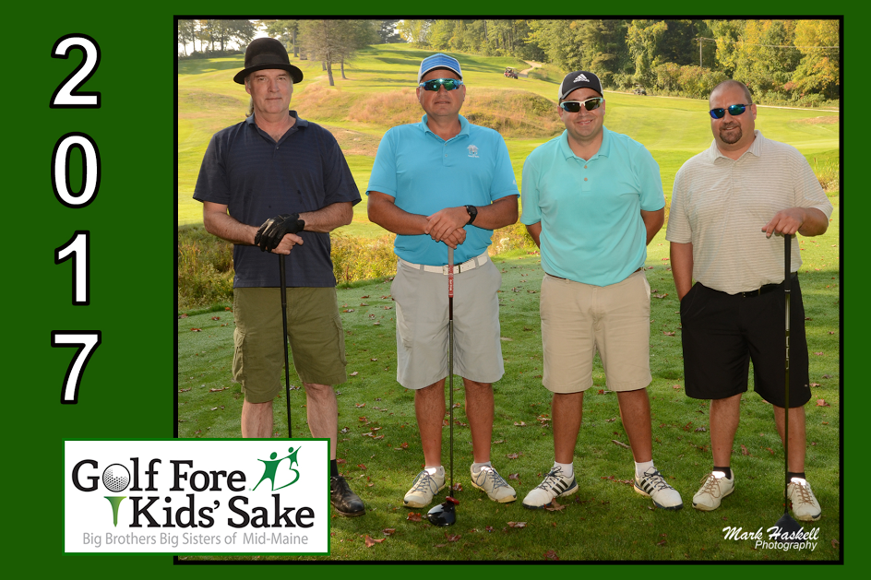

The top Net Team was “Team Mark” team members included: Jon Dudley, Felix Lincoln, David Busch, Mark Breton

Big Brothers Big Sisters of Mid-Maine’s mission is to provide children facing adversity in Androscoggin, Kennebec, Knox, Lincoln, Penobscot, Somerset, and Waldo counties with strong and enduring, professionally supported 1-to-1 relationships that change their lives for the better, forever.

For more information on the next golf tournament, to volunteer, or to find out how you can make a difference in the lives of local children facing adversity, contact Jennifer Cartmell at 207-653-3857 or email: jennifer@bbbsmidmaine.org.

