48 Washington Street, Suite 16
Camden, ME 04843
Phone: 236-BBBS Fax: 236-2292
info@bbbsmidmaine.org
www.bbbsmidmaine.org

September 29, 2017

FOR IMMEDIATE RELEASE
CONTACT: Monica Charette (314-6996)

Golf Fore Kids’ Sake Raises $30,000 in Support of Big Brothers Big Sisters Youth Mentoring in Kennebec Valley

Big Brothers Big Sisters of Mid-Maine’s 2017 Golf Fore Kids’ Sake, Presented by Kennebec Savings Bank raised $30,000 to benefit school and community-based mentoring services for children in Kennebec and Somerset counties. Twenty-two teams competed in the 18th annual golf tournament, held September 1 at Belgrade Lakes Golf Club.

2017 Golf Fore Kids’ Sake Tournament Winners:
1st Gross –Charlie Shuman, Stephen Shuman, Ryan Madore, Andy O’Hearn (Charlie’s Family of Dealerships)
2nd Gross – Jason Gall, Ed Gall, Mark Plummer, Jim Quinn (Wendy’s)
3rd Gross – Eric Gosline, Geoff Houghton, Patrick Cunningham, Steve Hildreth (Gosline Insurance)

1st Net – James Sanborn, Laura Rowe, Brian Beaulieu, Dan Wyman (GHM Insurance/Allen Insurance & Financial)
2nd Net – Lance Quinn, Luke Takatsu, Devon Grenier, Tim Carlson (Darling’s Chrysler Dodge Ram Hyundai)
3rd Net – Richard Morin, Ed Frye, Phil McCabe, Richard Breton (Kennebec Valley Federal Credit Union)

Course Challenge Winners
Straightest Drive – Pete Labbe (Cives Steel)
Closest to the Pin Contest – Gard Deletetsky (Great Falls Marketing)
Putting Contest – Tim Carlson (Darling’s Chrysler Dodge Ram Hyundai)
Hit the Green Contest – Pete Labbe (Cives Steel)
Chipping Contest – Eric Gosline (Gosline Insurance)
A hole-in-one challenge was sponsored by Charlie’s Family of Dealerships. Golfers were treated to breakfast, sponsored by Aroma Joe’s, snacks and water were provided by Pine State Trading and lunch was sponsored by The Red Barn. Valley Distributors and Rita’s Catering, sponsored the Awards Reception. An auction with sponsor-donated prizes raised $5,500 and “ShineOnCass” sponsorships, in memory of Big Sister Cassidy Charette, raised nearly $4,000 for local school-based mentoring programs.

Big Brothers Big Sisters of Mid-Maine changes the lives of over 700 children facing adversity in Androscoggin, Kennebec, Knox, Lincoln, Penobscot, Somerset and Waldo counties, for the better, forever by providing strong and enduring, professionally-supported, one-to-one relationships. By partnering with parents, volunteers and organizations, children in Big Brother Big Sister programs have higher aspirations, greater confidence, better relationships, avoid risky behaviors and achieve educational success. For more information call 236-BBBS (2227) or email info@bbbsmidmaine.org.

Photos:

Big Brothers Big Sisters of Mid-Maine Golf Fore Kids’ Sake at Belgrade Lakes raised $30,000 for mentoring services that benefit local kids facing adversity in Kennebec and Somerset counties.
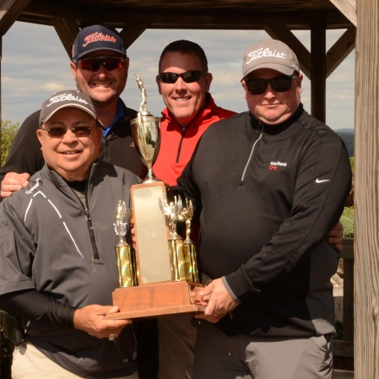

Winning the First Place Gross prize in this year’s event was Charlie’s Family of Dealerships (L to R): Charlie Shuman, Stephen Shuman, Ryan Madore and Andy O’Hearn.

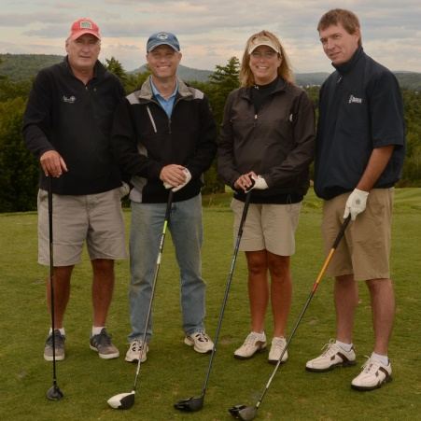

First Place Net Award was presented to GHM Insurance/Allen Insurance & Financial:
(L to R): Dan Wyman, Brian Beaulieu (Allen Agency) Laura Rowe and James Sanborn (GHM

